Joining a Domain
By
Joseph Tierney

Class: Computer Science 2

Tutor: Tony Bernes

To set up a scope for the server, run DHCP from the start menu. Click Programs and Administrative tools, there you will find DHCP. Click the server in the next window and click New Scope. In the welcome screen, click Next. In the New Scope Wizard, enter the name and the description of the scope and click next.
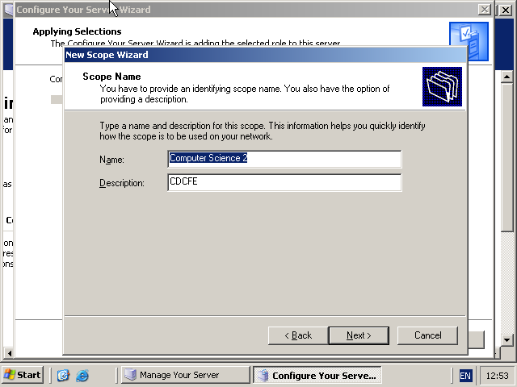

For the IP Address Range page, set the start IP Address to 192.168.1.10 ad the End IP Address to 192.168.1.50

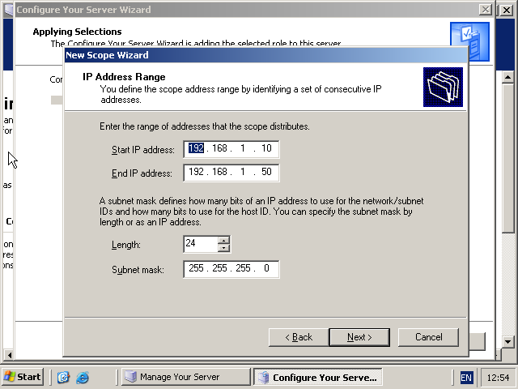
To join a domain, go to System Properties by going to Control Panel, System and Security. In the system properties, click Computer Name. Click Change and in the Computer Name text box, enter the name of the computer. In the Member Of section, click Domain and enter the name of the domain.
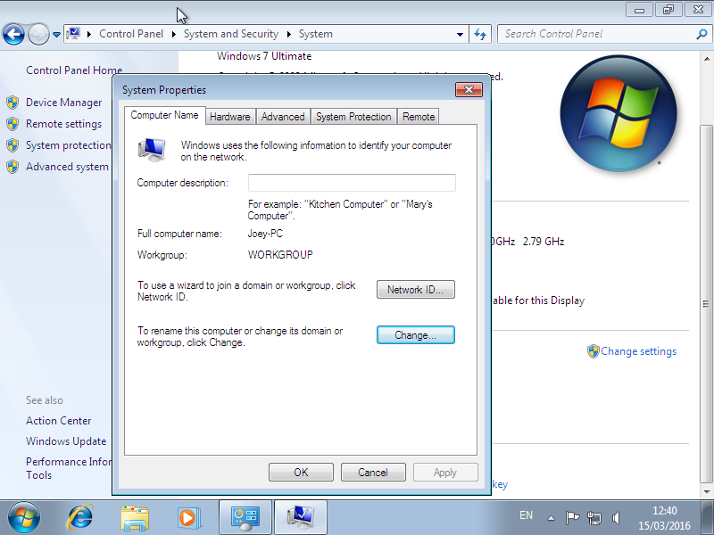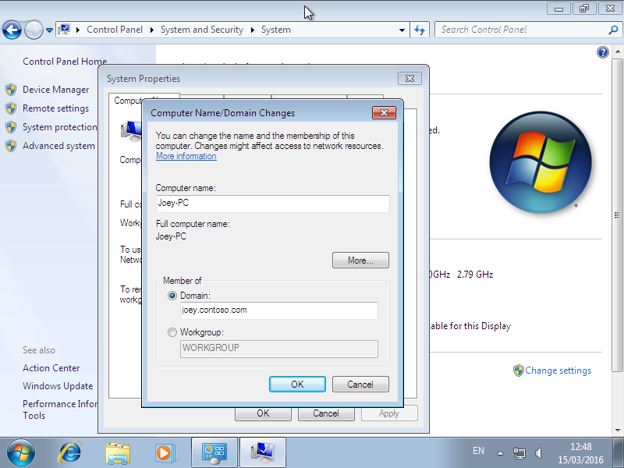

After entering the name of the computer and what domain to join, click OK. Then enter the username and password for the user who has permission to let a computer join the domain. After entering the information, click OK and if you have the right to add computers, you will receive a welcome message. Click Ok.

